Glenfield Primary School


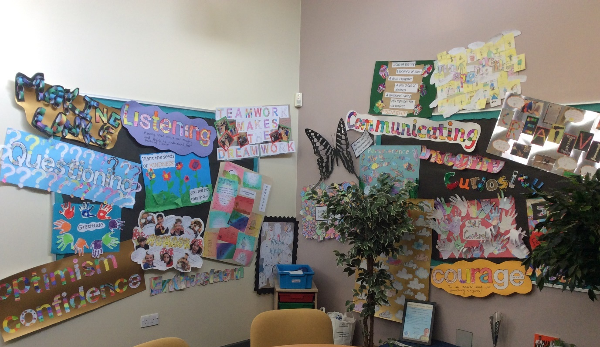
SEND Information Report 2025
“The school is inclusive and aspirational. Staff adapt the curriculum well to meet the needs of pupils with special educational needs and/or disabilities (SEND). This includes a significant number of pupils with EHC plans who attend the SEN unit, known as the Speech and Language Provision. These pupils receive excellent care and support to access the same curriculum as their peers whenever they can.”
Ofsted Report May 2024

Contents
- Overview of information for parents and carers of children with Special Educational Needs and Disabilities (SEND)
- What types of SEND does the school provide for?
Identification
- How does Glenfield Primary School identify and assess children with Special Educational Needs?
- Who do I contact if I have concerns or questions about my child?
Provision
- What is Glenfield Primary School’s approach to teaching pupils with Special Educational Needs?
- How do we adapt the curriculum and learning environment for pupils with Special Educational Needs?
- What are the arrangements for assessing and reviewing the progress of pupils with SEND?
- What support is available for improving the emotional, mental and social development of pupils with Special Educational Needs?
- What expertise and training do staff have?
- How are pupils supported between phases of education?
Effectiveness
- How do Glenfield Primary school involve parents, carers and families in supporting children with SEND?
- How do Glenfield Primary school support parents of children with SEND?
- How do we evaluate the effectiveness of provision for pupils with SEND?
- What are the arrangements for consulting and involving young people in their education?
- What should I do if I have a concern, I am worried or unhappy?
Other information
- Where can I find out more information about the support services available to pupils with SEND needs?
- Where can I find the Local Authorities Offer?
- Accessibility Policy
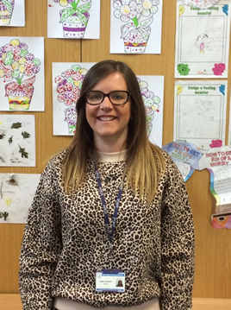
Our Staff


Miss Stretton Mr Squires
SENCO (Head of Speech and Language Provision)
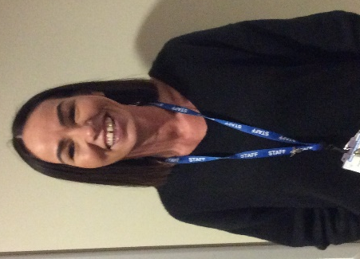

Mrs Elkington
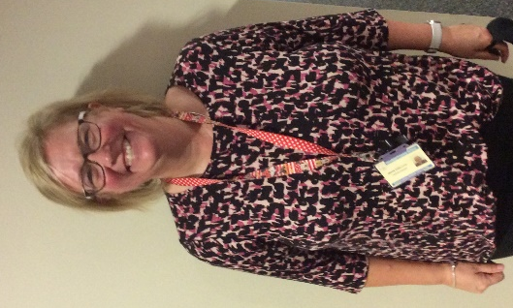
Parent Officer

Miss Harris Mrs Osborne
ELSA ELSA
Overview of information for parents and carers of children with Special Educational Needs and Disabilities (SEND).
Glenfield Primary School is a mainstream setting catering for children aged from 4 to 11 years old with 429 pupils on roll. Within the school, we also have a specialist Speech and Language Provision which currently meets the needs of up to 30 pupils. All children within the provision have a statement of special education need with speech and language as their primary need.
At Glenfield Primary we strive to support all children to enable them to achieve and become active participants in their education. In order to do this, many steps are taken to support them through their learning journey and we recognise that every child is entitled to a broad and balanced curriculum which is relevant to their individual needs. We are an inclusive school and we value every child. We strive to provide an environment where all children can flourish and feel safe.
What types of SEND does the school provide for?
Area of Need | Condition
Communication and Interaction | Autistic spectrum condition
Communication and Interaction | Speech and Language Difficulties
Cognition and Learning | Specific learning difficulties including dyslexia, dyspraxia, dyscalculia
Cognition and Learning | Moderate Learning Difficulties
Cognition and Learning | Severe Learning Difficulties
Social, emotional and mental health | Attention deficit hyperactive disorder
Social, emotional and mental health | Attention deficit disorder
Sensory and/or physical | Hearing Impairments
Sensory and/or physical | Visual impairments
Sensory and/or physical | Multi-sensory impairment
Sensory and/or physical | Physical impairment
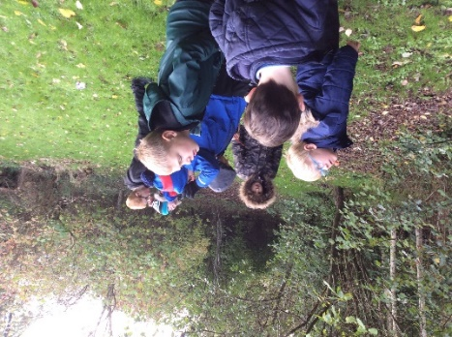
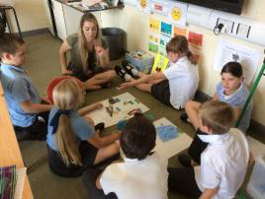

Identification

How does Glenfield Primary School identify and assess children with Special Educational Needs?
All our class teachers are aware of SEND and quickly identify any pupils who aren’t making the expected level of progress in their schoolwork or socially.
If the teacher notices that a pupil is falling behind, they try to find out if the pupil has any gaps in their learning. If they can find a gap, they will give the pupil extra intervention or adapted learning to try to fill the gap. Pupils who do not have SEND usually make progress quickly once the gap in their learning has been filled.
If the pupil is still struggling to make the expected progress, the teacher will talk to the SENDCo and will contact parents to discuss the possibility that their child has SEND.
The SENDCo will observe the pupil in the classroom and in the playground to see what their strengths and difficulties are. They will have discussions with the pupil’s teacher/s to see if there have been any issues with, or changes, in their progress, attainment or behaviour. They will also compare the pupil’s progress and development with their peers and available national data.
The SENDCo will ask for the parents opinion and speak to the pupil to get their input as well. They may also, where appropriate, ask for the opinion of external experts such as a speech and language therapist, an educational psychologist or a paediatrician.
Based on all of this information, the SENDCO will decide whether the pupil needs SEN support. You will be informed of the decision formally.
If the pupil does need SEND support, their name will be added to the school’s SEND register and the SENDCo will work with the pupil, parents and teachers to create a SEND support plan for them (Passport for learning). Passports and one page profiles are created and implemented using new edukey online software, which allows all staff working with SEND pupils quick access to their learning targets.

Children requiring SEND Support
The indicators for a pupil receiving SEND Support to have a SEND Support Plan may be:
• Continues to make little or no progress in specific areas over a long period
•Continues working at National Curriculum levels substantially below that expected of children of a similar age
•Continues to have difficulty in developing literacy and numeracy skills
•Have social, emotional and or mental health difficulties which substantially and regularly interfere with the child’s own learning or that of a class group, despite having an individualised plan
•Has sensory or physical needs, and requires additional specialist equipment or advice or visits by a specialist service
•Has ongoing communication or interaction difficulties that impede the development of social relationships and case substantial barriers to learning.
A pupil with a SEND Support Plan may have the involvement of external support services, both those provided by the Local Authority and by outside agencies. These will be consulted to provide more specialist assessments and to advise teachers about strategies including more personalised targets to address individual needs where required. Parents are always consulted before an external agency is involved.


Education, Health and Care Plan (EHCP)
If a pupil, despite the school having taken relevant and purposeful actions to identify, assess and meet the SEN of the child or young person, has not made expected progress, the school will consider requesting an Education, Health and Care needs assessment. The school will provide evidence of the action it has taken in the form of a SEND Support Plan to inform the Local Authorities decision.

The Local Authority considers the need for an EHCP and arranges, monitors and reviews provision.

Who do I contact if I have concerns or questions about my child?
Tell us about your concerns |  | We will invite you to a meeting to discuss them. |  | We will decide whether your child needs SEND support.
If you think your child might have SEND, the first person you should tell is your child’s teacher. |  | We will meet with you to discuss your concerns and try to get a better understanding of what your child’s strengths and difficulties are |  | If we decide that your child need SEND support, we will formally notify you and your child will be added to the school’s SEND register.
Appointments can be made directly with the class teacher or via the school office. |  | Together we will decide what outcomes to see for your child and agree on next steps.
Class teachers will liaise with the SENDCo as appropriate. |  | We will make a note of what has been discussed and add this to your child’s record.
You can also contact the SENDCo directly:
sen@glenfield.leics.sch.uk


Provision
What is Glenfield Primary School’s approach to teaching pupils with Special Educational Needs?
At Glenfield Primary School teachers seek to meet the diverse needs of all children including children with SEND by employing a variety of approaches to learning, teaching and assessment. Wherever possible we try to reduce or remove barriers to learning so that every child can reach their full potential.
The systems in place include:
- All pupils learning is planned by their class teacher. It will reflect their individual needs.
- Our curriculum incorporates a variety of learning styles to deliver quality first teaching to all pupils.
- Children’s views are taken into account with regard to their learning targets in line with their age and level of understanding.
- Setting achievable targets and provision put in place guided by a pupils needs
- If your child has needs related to more specific areas of their education, such as spelling, handwriting, mathematics, staff may be allocated to work with a pupil on a 1:1 basis or he/she will be placed in a small focus group. These groups will be run by the teacher or teaching assistant and may involve some pre-teaching to help pupils to be “ready” for the whole class work.
- Specialist equipment may be used depending on your child’s needs, for example a writing slope, sensory calming tool, coloured overlay.

How do we adapt the curriculum and learning environment for pupils with Special Educational Needs?
At Glenfield Primary we strive to support all children to enable them to achieve and become active participants in their education. In order to do this many steps are taken to support them through their learning journey and we recognise that every child is entitled to a broad and balanced curriculum which is relevant to their individual needs.
For those children who find it difficult to access the curriculum, we are flexible in our approach to ensure they can access learning that is appropriate and relevant to their development. We may adapt the curriculum in a number of ways, including:
•Adaptation – making the teaching and learning match the needs of the children. This could mean simplifying the work or providing scaffolding.
•Pre-Teaching – to ensure a child can fully engage with the curriculum, sometimes it is necessary to pre-teach elements they may find difficult, for example vocabulary, methods etc.
•Resources – A child with SEN may need access to additional resources to develop their learning. Practical equipment can help a child to complete tasks independently.
•Adapting outcome or presentation – by changing the outcome or presentation a child with SEN may be more successful in accessing the curriculum.
•Additional Support – Sometimes a child may receive additional support from a Teaching Assistant to enable them to complete tasks.
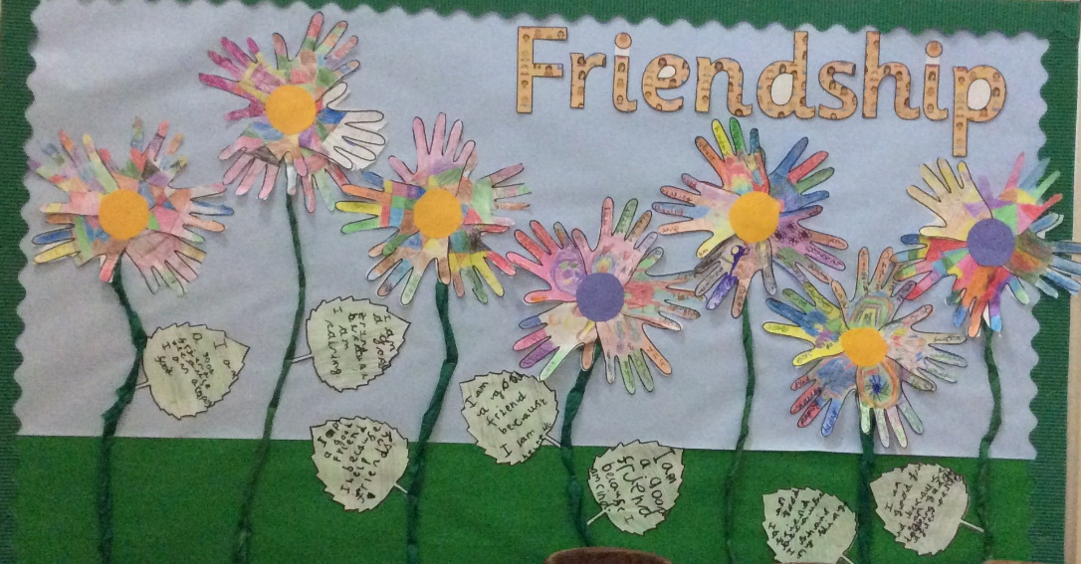

At Glenfield Primary we understand that children learn in different ways. We try to make our classrooms inclusive for all learning styles:
•Ensuring our classrooms are calm, positive and distractions are minimised
•Clear expectations for learning and behaviour
•Rewarding good behaviour
•Displaying good quality work from all pupils to show we value effort
•Access to learning aids and practical equipment.

What are the arrangements for assessing and reviewing the progress of pupils with SEND?
We will follow the ‘graduated approach’ to meeting the pupil’s SEND needs.
The graduated approach is a 4-part cycle of assess, plan, do, review.
Assess | If the pupil is not making the expected level of progress, we will make an assessment to find out what strengths and difficulties the pupil has. We will ask for parents and the pupil’s input as well as getting help from external professionals where necessary.
Plan | In discussion with parents and the pupil, we will decide what outcomes we are hoping to achieve. We will make a plan of the support we will offer the pupil to help them meet those outcomes. We will make a record of this and share it with the parents and all relevant school staff.
Do | We will put our plan into practice. The class teacher, with the support of the SENDCo, will be responsible for working with your child on a daily basis and making sure the support that has been in place is having the impact we intended.
Review | We will assess how well the support we put in place helped the pupil to meet the outcomes we set. We will use our improved understanding of the pupil’s needs to improve the support we offer.

As part of the planning stage of the graduated approach, we will set outcomes, through the passport for learning, that we want to see the pupil achieve.
The process will be continual. If the review shows a pupil has made progress, they may no longer need the additional provision made through SEND support. For others, the cycle will continue and the school’s targets, strategies and provisions will be revisited and refined.
- You will be able to discuss your child’s progress at parents’ evening which are held twice a year.
- If your child has an individual pupil passport, meetings are held termly to discuss how your child is doing and what further steps need to be taken to enable your child to make progress in their learning.
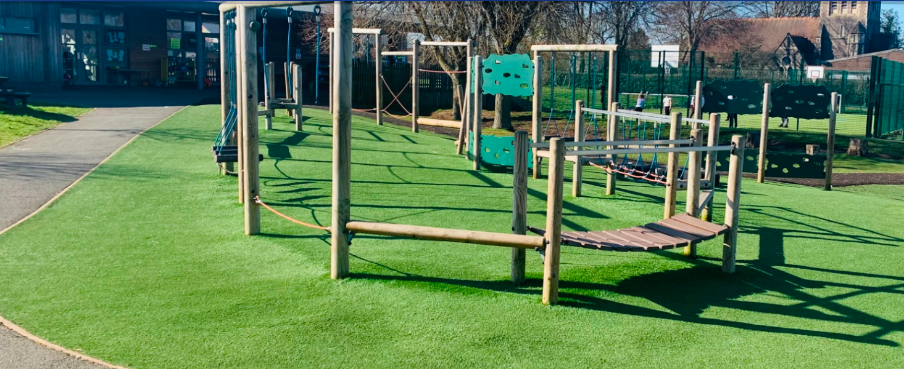
If your child has an EHCP you will be invited to contribute in writing to the review process and to attend the annual review. As part of the review process parents and children are consulted to obtain their views and these are incorporated in to the child’s individual learning passport as part of the assess, plan, do and review process.
For some children, meetings may need to be held more frequently.
Please contact your child’s class teacher if you would like a meeting.

What support is available for improving the emotional, mental and social development of pupils with Special Educational Needs?
At Glenfield Primary School, we recognise the importance of emotional wellbeing and offer a variety of support mechanisms for pupils who are encountering emotional difficulties. The whole school focuses on developing a positive, growth mindset in order to encourage children to become happy, independent, life-long learners. All of our staff are trauma informed trained. Alongside this, we also incorporate the Zones of Regulation into our daily routine to provide children with a metacognitive pathway to support their emotional regulation.
We encourage pupils to contribute to their one-page profile outlining their strengths and ways they feel others could best support them.
We have two teaching assistants (Mrs Osborne and Miss Harris) who are trained as Emotional Literacy Support Assistants (ELSA). They can offer support for a range of issues including bereavement, family break-up and friendship issues.
Our teaching assistants also run social and communication groups which focus on developing confidence, self-esteem, turn-taking, cooperation and social skills.

What expertise and training do staff have?
- All staff are made aware of their responsibilities towards pupils with special educational needs.
- The SENCO provides training to teachers and support staff on a wide range of issues and is also available for individual advice.
- For more specialist provision, there are a number of staff that are now trained in Team Teach.
- All of our staff are Trauma informed trained.
- Staff update training on a continual basis for how to support children on the autistic spectrum, support pupils with speech and language difficulties, physical and co-ordination needs and children with specific learning difficulties.
- The SENCo has achieved the qualification “National Award for Special Educational Needs Co-ordination”.
- The SENCo keeps up to date on current local and national changes by attending meetings.
- The school works with a number of outside agencies to seek advice and support individual children.

How are pupils supported between phases of education?
Many transition systems are in place, depending on whether your child joins in foundation, part way through a year or at the beginning of an academic year:

- Foundation – the minimum transition will include a telephone conversation with the previous setting. Usually, foundation staff go to the early years setting and speak to the staff to gather information. There are lots of opportunities for you and your child to visit Glenfield prior to starting school.
- In some cases, the class teacher and SENCo will visit your child in the setting and invite members of the setting to come over with your child and visit Glenfield.
- Additional visits are arranged for children who need extra time as they might find the change challenging.
- Discussions between the previous or receiving school prior to your child joining or leaving are important to ensure a smooth handover.
- Year 6 transition to Year 7 – we have good links and work closely with our local secondary schools. We start to give information about the secondary transfer to you as your child approaches the end of year 5.
- If your child has additional needs, or is on the SEND record, then the SENCo has a transition meeting with the secondary setting SENCo and sets up meetings for parents in advance of your child moving on. Additional visits are also arranged for the child to become familiar with the school.
- Local secondary staff visit pupils and staff at Glenfield prior to them joining their new school.
- All pupils attend transition sessions at their new secondary setting to meet their new teachers.
- Staff are always willing to meet new parent/carers prior to them joining Glenfield.
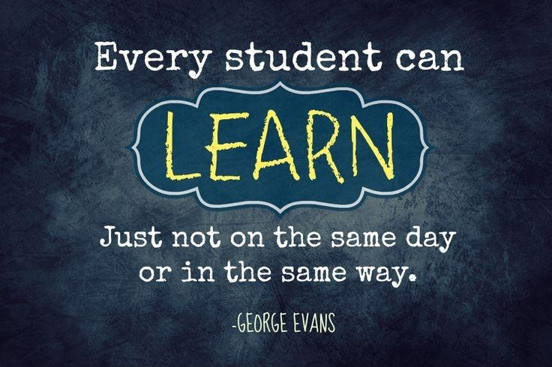
Effectiveness
How do Glenfield Primary school involve parents, carers and families in supporting children with SEND?
At Glenfield Primary School we are committed to the development of close working relationships with parents and recognise the importance of such relationships when supporting children with special needs.
Curriculum leaflets are sent home on a termly basis outlining what the children will be learning.
On the child’s individual learning passport, there will be examples and ideas of how you can help to support your child in meeting their individual learning targets. You will be invited to a termly student passport meeting to review and set targets.
If your child has an EHCP you will be invited to contribute in writing to the review process and to attend the annual review.
We hold coffee mornings/afternoons with SEND parents to allow them to liase with the SENCo, gather information from the school or share tips and advice with other parents.
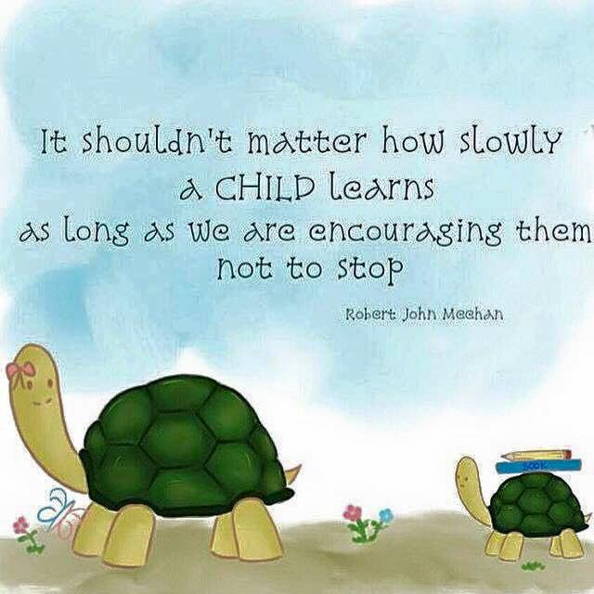

How do Glenfield Primary school support parents of children with SEND?
As a school we support parents of children with SEND in a number of different ways which include:
- We hold meetings or phone calls with SEND parents at least three times during the academic year. The focus of these meetings is to discuss the child’s individual targets, progress the child has made and any further support the child requires.
- We capture parent’s voice throughout the academic year by sending out parent questionnaires. We then action as best possible the outcomes from these questionnaires.
- We provide advice and resources for parents of how they can support their child to meet their individual passport targets.
- The SENCO and/or class teachers hold meetings with parents to discuss any external agency visits.
- School staff support parents in attending external agency meetings by attending with the parents if they request.
- We provide transitional support for both SEND children and parents by visiting other schools with them if needed or support in contacting other schools or services to support effective transition.
How do we evaluate the effectiveness of provision for pupils with SEND?
The SENCO and the Senior Leadership Team specifically monitor provision for children with SEN. This takes many forms:
• Lesson/intervention observation
• Book scrutiny
• Learning walks
• Discussions/questionnaires with staff and pupils
• Passport for Learning monitoring
• Analysing data.
• Annual reviews
• Attending multi agency meetings and using feedback from outside agencies.

The SENCO will ensure that provision is effective for these pupils.

What are the arrangements for consulting and involving young people in their education?
At Glenfield Primary we encourage pupils to contribute individually to help determine the direction of their learning and personal development by:
• Involving the child in his/her individual pupil passport (including their strengths and weaknesses) and ensuring they are aware of their individual targets.
• Having the opportunity to take part in the school council which enables pupils to have their voices heard and take part in decision making.
• Involving pupils in annual reviews either before the review or if appropriate to attend the review.
• Involving pupils in writing their one page profiles which are very pupil led.

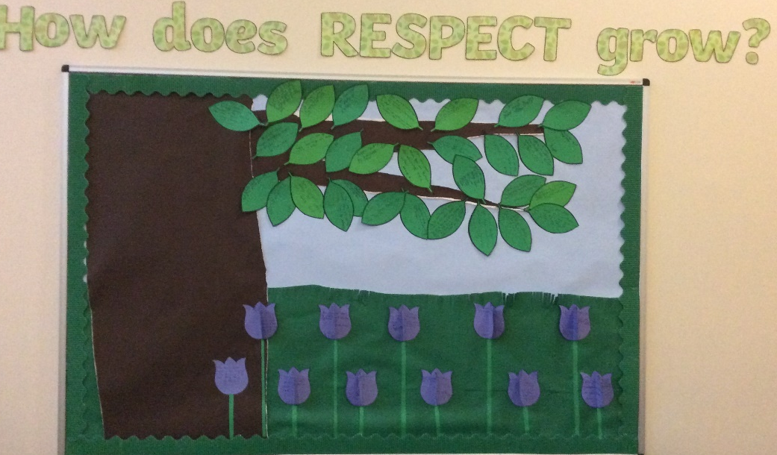

What should I do if I have a concern, I am worried or unhappy?
At Glenfield Primary we try hard to work in collaboration with parents and parents are encouraged to discuss any problems or concerns with schools. If there are any concerns relating to the support for pupils with SEN, then parents need to speak with:
- The class teacher in the first instance
- The SENCo
- The Deputy Headteacher
- The Headteacher

Further information about making a complaint can be found in our Complaints Policy.

Other Information
Where can I find out more information about the support services available to pupils with SEND needs?
 | School Nurse | 0116 215 3269
 | Confidential help and advice – its safe and easy for you to speak to a qualified health professional. Just send a message, you don’t have to give your name | https://chathealth.nhs.uk/
 | Leicestershire Educational Psychology Service – There is useful information for you to view on the website. | https://www.leicestershire.gov.uk/education-and-children/special-educational-needs-and-disability/education-and-childcare/educational-psychology-service  Wednesday 9am to 11.30 am term-time only 0116 3055100  psychology@leics.gov.uk
 | Specialist Teaching service – offers free support and advice to school and families about specific areas of SEND. | https://www.leicestershire.gov.uk/education-and-children/special-educational-needs-and-disability/education-and-childcare/specialist-teaching-service
 | Autism Outreach, Hearing support team, Vision support team | 0116 305 9400  sts@leics.gov.uk
 | Children’s speech and language therapy service | 0116 295 5256  You can access the referral form on: https://www.leicspart.nhs.uk/fypc-referral-form/
 | Children’s Occupational Therapy – help children who are experiencing difficulties with gross and fine motor skills, visual perception, sensory impairment and sensory motor skills. | 0116 295 2495  Fypc.referrals@nhs.net  You access the referral form on: https://www.leicspart.nhs.uk/services/referrals/?v=12925  There are lots of useful resources on: https://www.leicspart.nhs.uk/services/help-support-resources/?v=12925
 | SENDIASS – provide free, impartial and confidential advice and support to parents and carers of young people aged 0-25 with special educational needs or disabilities as well as young people themselves. | https://sendiassleicestershire.org.uk/  0116 305 5614  info@sendiassleicestershire.org.uk
 | A useful website of a charity who can support the young person, parents or people working with the young person. | https://www.youngminds.org.uk/
 | Children and Family Wellbeing Service – provide support for children who are suffering from domestic abuse, mental health and wellbeing, extra help with SEND, parenting or supporting vulnerable young people. | https://www.leicestershire.gov.uk/education-and-children/social-care-and-supporting-families/children-and-family-wellbeing-service  0116 3058727
 | Resources, downloads, talks and videos to help understand more about ADHD and neurodiversity and how you or your family can be supported. | https://www.adhdfoundation.org.uk/resources/

Where can I find the Local Authorities Offer?
All local authorities working with their partners must publish information about how children and young people 0-25 with Special Educational Needs and Disabilities are supported in their area. The local offer describes the services and support available for Children and Young People with SEND from birth to 25 and their families in Leicestershire. You can find information, help and advice; assessments; plans and policies throughout this section of the website:
http://www.leicestershire.gov.uk/education-and-children/special-educational-needs-and-disability/about-the-local-offer
Glenfield Primary School intends to link closely and align itself to the local authority offer.

Accessibility Policy
Please find a copy of the school’s accessibility policy on the website.

