

Glenfield Primary School

Positive Behaviour Policy

Date of Review | August 2026
Next Review Date | August 2027
Headteacher | Sukhi Tibbles
Chair of Governors | Tessa Wildgoose

At Glenfield Primary School our mission statement is…
“Learn together, achieve together, be the best that we can be.”

This is driven through our school in our approach to behaviour with a consistent narrative of:
Be Safe, Be Ready, Be Respectful.

Policy aims and objectives
It is a primary aim that every member of the school community feels valued and respected, and
that each person is treated fairly. We are a caring community whose values are built on mutual
respect and trust for all. We aim to create an environment in which everyone feels happy, safe
and secure. Therefore, our school’s behaviour policy is designed to support the way in which all members of the school can live and work together and is built on an ethos of high expectations. It aims to promote an environment centered around our school’s three rules where everyone is safe, ready and respectful.

It is acknowledged that members of the school community may have very different parenting experiences and views on behaviour. However, the aim of our Positive Behaviour Policy is to bring us all together to adhere to some basic key principles and practices that reflect our school ethos.

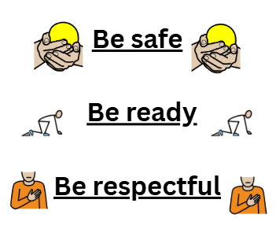

Our School Ethos
Everything we do starts with positive relationships – building, maintaining, and repairing them. We believe that children deserve our time – time to talk, to explain and to find solutions.

At Glenfield Primary School, we believe in and practice a relationship-based and restorative approach to understanding behaviour. This approach is underpinned by three key principles:

  - Unmet Needs: Behaviour often reflects unmet needs. Therefore, to change behaviour, we must respond to the unmet need e.g. the need to feel safe, hunger, positive self-esteem.
  - Individual Influences: Children’s behaviour cannot be fully understood in isolation. It needs to be understood within the contexts or environments in which they develop e.g. their family, community, school.
  - Relationships: Within trusted relationships, children can learn, accept their individual strengths, accept areas for development, and explore strong emotions and experiences.

As a school, we remember that discipline means to teach, not to punish. So, in order that we provide opportunities for children to learn positive behaviours, unconditional positive regard is
central to our school ethos.
    - We know that empathy is at the core of building positive relationships: the ability to share someone else’s feelings or experiences by imagining what it would be like to be in that person’s situation.
    - We also appreciate the gravity of acting ‘In Loco Parentis’ (in place of a parent). We have a duty of care towards our children, promoting safety and welfare. The level of this duty of care is measured as being that of a ‘reasonable parent.’
    - We know that, as adults, ‘we make the weather’ and it is up to us to ensure that all children feel safe and happy.

School Rules
Our “School Rules” are displayed in every classroom and around school. Our “School Rules” are as follows:

- Be Safe
- Be Ready
- Be Respectful

Be Safe
Within our school environment, we adhere to a set of expected behaviours to ensure safety and well-being for all. It is our practice to promptly follow instructions provided by school staff, seek assistance when needed, and refrain from physical interactions by keeping our hands and feet to ourselves. Moving around the school premises is done calmly and respectfully, showcasing responsible decision-making and proper handling of equipment. Moreover, we uphold a culture where any concerning behaviour observed is promptly reported to a supervising adult, reinforcing the importance of maintaining a safe and secure learning environment at all times.


Be Ready
In our school, readiness is reflected in every facet of our behaviour. This encompasses arriving promptly at school each day, demonstrating a sense of responsibility by wearing our correct uniforms and ensuring we have suitable attire for PE lessons. Following break and lunch times, we exhibit our readiness to learn by standing quietly behind our chairs. We approach learning with a positive mindset, displaying attentiveness by listening carefully and adhering to instructions promptly. Our demeanour is characterised by composure and focus, sitting upright and engaging fully with the lesson. Transitioning between tasks is conducted swiftly and silently, while lining up in an orderly fashion at all times. Above all, we strive to give our utmost effort, aiming for excellence with a dedicated 10/10 commitment in all our endeavours.



Be Respectful
In our school, being respectful is a key part of our behaviour curriculum. We instil in our pupils the importance of walking sensibly and silently around the school, ensuring they walk on the left-hand side in the corridors. It is essential that our students demonstrate fantastic listening skills when engaging in conversations, whether with adults or peers. Simple acts such as greeting with 'good morning' and 'good afternoon', holding doors open for others, and exhibiting politeness and good manners towards everyone are actively encouraged. We foster an inclusive environment where we celebrate the diversity and differences among our students. Additionally, we emphasise the responsibility of taking care of our classrooms, school equipment, and the environment. Encouraging kind and calm speech towards each other is fundamental to promoting a respectful school ethos.


See Appendix 1 “Our School Rules”
See Appendix 2 “Our Routines”
These further the implementation of safe, ready, respectful into our school culture.

Our school rules are underpinned by our school values. The rules will be woven through the values ensuring the values are rewarded and worked towards. The school values are as follows:
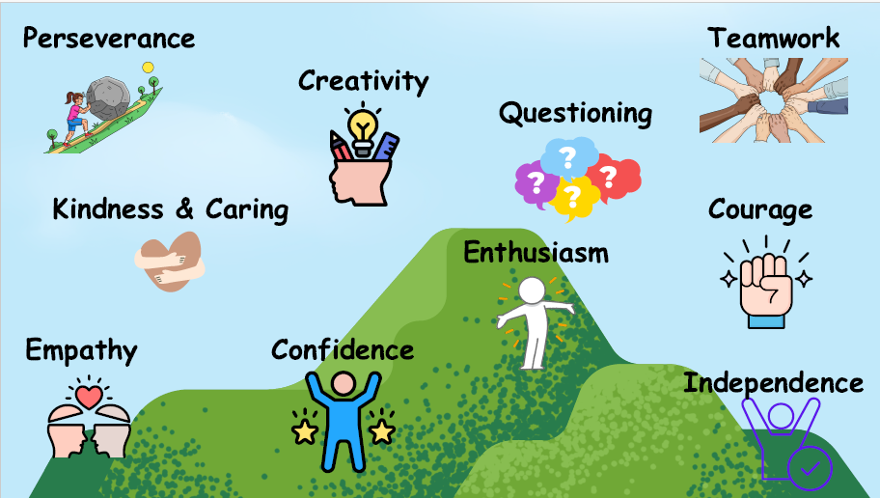

Throughout our fortnightly achievement assembly, the children will be rewarded based on these values using the school rules as a prompt.

Teaching Behaviour Expectations
Our behaviour expectations are explicitly taught and reinforced through a range of approaches across the school.
Assemblies play an important role in this, where our school values, British Values, and the Protected Characteristics are regularly discussed to promote understanding, respect, and tolerance. These themes are further embedded within our PSHE curriculum: in the autumn term, all year groups complete a unit on Respecting Ourselves and Others, which focuses on positive relationships, mutual respect, and responsible behaviour; in the spring term, the Belonging to a Community unit reinforces our expectations of kindness and inclusion; and in the summer term, the Keeping Safe unit supports children's understanding of how to make safe and responsible choices. In addition, our Computing curriculum includes explicit teaching about safe and respectful behaviour online.
Where specific needs arise—for example, if particular behaviour issues occur within a class, teachers will tailor or deliver additional lessons to address these directly and constructively.
Together, these approaches ensure that the teaching of positive behaviour is ongoing, embedded, and responsive to the needs of all pupils.

Promoting good behaviour
Children learn best and behave best when they know what is expected of them and when they are positively encouraged to behave well. They need to have plenty of opportunities to experience success and also need to be aware that if they do not behave appropriately, they will be consistently and fairly treated. It is therefore important to focus on positive behaviour strategies and our policy and practice reflect this. It is inevitable that some instances of inappropriate behaviour will occur - no positive feedback system will be effective with all children all of the time. Sanctions do, therefore, have a place within the school’s behaviour policy, but they are most effective when used within an environment in which positive strategies are used as a first resort.

Rewards
It is a firm belief at Glenfield Primary School that children are rewarded for positive behaviour. This positive recognition reinforces the positivity that we expect in school. Our high expectations are applied consistently across school and are expected of our children, our staff, and our wider school community.
We praise our children in a variety of ways:
- Verbal praise and smiles
- Whole class reward systems
- Individual rewards
  - Class sticker/stamps
  - Public praise in front of staff
  - Visit Headteacher, Deputy Headteacher or member of SLT for praise
  - Dojo Points
  - Proud post from teacher to families
  - Golden Letters from the Headteacher
  - Star of the Week
  - Head Teacher Award in achievement assembly
  - Pride of Glenfield Award

Whole class reward systems
These are designed so that the class know that they are being rewarded for working hard as a team and by respecting our agreed school rules and values. The children are working towards a whole class treat each ½ term that will last about 1 hour. This will be achieved once the class fills up marbles in the jar. The reward is decided between the class teacher and the children.
Individual Rewards
At Glenfield Primary School, we recognise that rewards need to be fair and equitable. Children are awarded individual Dojo points and work towards certificates (50 bronze, 100 silver,150 gold, 200 platinum, 250 star treat). Points focus on children showing the above and beyond behaviours linked to the school values (see appendix 8). Dojo Points can be awarded by any member of staff both inside and outside the classroom, however only one dojo point may be awarded at any one time.
Achievement Assembly – Headteacher’s certificate
Children from each class are awarded a Headteacher’s certificate presented in a celebration assembly every fortnight. Certificates focus on the school values and rules.

Proud Post
Children will receive a “Proud Post” from their teacher whenever it is felt to be appropriate. This will be awarded when the teacher believes a child has done something during the day that they should be proud of. Children will take the ‘Proud post’ home so that parents/carers can share in celebrating the achievement.

Golden Letter from the Headteacher
One child from each class is sent a golden letter direct to their home address acknowledging and celebrating their commitment to displaying the whole school values and rules. These letters are sent at the end of every term.

Star of the Week
Every week, a ‘star of the week’ trophy will be rewarded to a child in each class. This is for a child who might have excelled in a piece of work, set a good example to others, or demonstrated the school values on a consistent basis. The trophy will then be returned to school by the end of the week in preparation for the following week.

Pride of Glenfield Award
At the end of the year, a child from EYFS/KS1 and a child from KS2 who is seen by his or her peers and by the school staff as being the most supportive or a champion of care and compassion receives the prestigious “Pride of Glenfield Award” with their parents invited to school to witness the presentation in an assembly at the end of the year.
A reward, once earned, must never be taken away from the child.

Behaviour Steps
A restorative approach to challenging behaviour
In support of our ethos, we apply the practices outlined in Appendix 3, “Responding in the moment”. We are aware that all behaviour happens for a reason and when we are dealing with children who are at climax point, it is essential to take into consideration de-escalation strategies and the ‘Stages of Distress and Support’ (see appendix 4). At that moment in time, the child may not be at a point to reflect on their behaviour or discuss their choices. It is paramount that any interactions with the child do not escalate the situation – the child needs to be given time and space.
At Glenfield Primary School, we promote the use of ‘natural consequences’, supported by a trusted adult, as these can help children to reflect on and change their behaviour. Examples include writing letters of apology, repairing any damage to property, or completing missed work during part of a playtime (but never the full playtime). If playtimes are being missed repeatedly, the teacher should consider whether there is a deeper underlying issue that needs to be addressed.

It is, however, recognised that sometimes a more structured and immediate approach is required to support the child. The intention behind this is that the child has time to reflect, away from the situation. The behaviour will always be assessed against the School Rules, and this will be explained clearly to the child.

Dealing with behaviour is a shared responsibility and it is expected that all staff support one another for the benefit of the child. There is a hierarchy of support and responsibility:

Step | Strategy | Approach | Script
1 | A reminder of expectations and rules | The adult will give a quiet calm reminder to the whole class of our high expectations in line with Safe, Ready, Respectful. This will be followed as quickly as possible with positive praise (repair). The adult will try to identify any unmet need, individual influences or relationship issues that may help them to understand the behaviour.  The adult will make any necessary adaptations to prevent the behaviour from continuing. | "Let's all remember our expectation to be Safe, Ready and Respectful. Thank you to everyone who is showing this and making positive choices."  "Let's all think about whether we are meeting our Safe, Ready and Respectful expectations. Thank you to everyone who is showing these values."
2 | A verbal warning | If the behaviour continues, an adult will give a verbal warning to the child through 1:1 direct conversation. The adult will explain which school rule has been broken and explain positively through a short restorative conversation how the rule should be followed. Adults must listen to the views of the child and proactively support them to reengage with their learning. | "I can see this is still difficult for you. Right now you're not showing our expectation of _____. That looks like _____. Help me understand what's happening for you, and we'll work together to help you get back on track."  "I can see this is still difficult for you. Our expectation is _____. At the moment, I can see _____. Help me understand what happened, and together we'll decide what you need to be successful."
3 | Reflection time in own class | The child will be asked to move from their working space to the class reflection area. The child will be given 5 minutes to reflect and regulate. The adult will refer to the restorative questions on their lanyard and support the child to return back to their task. Where appropriate, the child may remain in the reflection area for a short period to regulate and re-engage with their learning before returning to their usual workspace. | "I can see you're finding this difficult right now. Let's move to the reflection area for five minutes so you have time to feel calm, think about what happened and get ready to return to your learning. I'll check in with you before you're ready to come back."  "I can see this is a tricky moment for you. Let's use the reflection area for five minutes to help you regulate and reflect. When I come back, we'll talk about what happened and how we can help you return to your learning successfully."
4 | Reflection Time in partner class. | The child will be asked to move to their partner classroom with work to complete. The child will be given 5 minutes to reflect and regulate. The adult will refer to the restorative questions on their lanyard and support the child to return to their class.  A message will be sent home via Class dojo by the class teacher using the following script. Until dojo is set up the following message will be sent via email:  Dear (parent/carer name)  I wanted to let you know that (child’s name) spent a short period of time in a partner classroom today to help them re-regulate and refocus. They took their work with them and were given 5 minutes to reflect and settle before returning calmly to their class. This message is to keep you informed. If you would like to discuss this further or would prefer a brief phone call, I am more than happy to arrange one.  Thank you for your continued support  (Teacher name) | "I can see you're still finding this difficult. Let's take your work to our partner classroom so you have five minutes to reflect and regulate. When you're ready, we'll talk about what happened and support you to return to class successfully."  "I can see you're finding it hard to regulate right now. Let's take your work to our partner classroom so you have five minutes to reflect and regulate. When you're ready, we'll have a conversation and support you to return to your class."
5 | Reflection with class teacher at break or lunch time | If the behaviour continues, the child completes a reflection (document provided – see appendix 9) with their class teacher and is followed up with a restorative conversation.  A phone call is then made to parents/carers by the class teacher to inform them of the reflection completed and the reason for this. Invitation for parents/carers to meet with the teacher but this is not an expectation.  Incident recorded on CPOMs by the class teacher including attaching the reflection document.

If behaviour poses a significant risk to the child or others, or involves behaviour that breaches the protected characteristics, the child will be referred to a member of the Senior Leadership Team (SLT). Wherever possible, any response will be restorative in nature. SLT will assess the circumstances and determine the most appropriate course of action, as outlined below.

6 | Reflection time with Inclusion Lead. | Adult to discretely ask the Inclusion lead to collect the child. The child will bring their work with them. The Inclusion Lead will have a restorative conversation with the child.  A phone call will be made to parents/carers by the class teacher.  Incident to be recorded on CPOMs.  Phase Leader to monitor behaviour over the remainder of the day/week.
7 | Reflection time with Headteacher or Deputy Headteacher | Phone call to parents by the class teacher – record on CPOMS.  Class teacher to arrange a meeting with parents to discuss behaviours.  A member of SLT to attend the meeting.
8 | Behaviour continues to escalate or continues to reoccur after above actions. | Follow up meeting with family, Inclusion Lead and member of the SLT – record on CPOMS.  Potential Internal Suspension.  Class Teacher: Develop personalised plans in collaboration with parents/carers and the Inclusion Lead. This may include SEND provision being put in place and/or Individual Behaviour Plan which is agreed and reviewed with parents and carers at least termly (or sooner if necessary).
9 | Relevant External agency support | School to contact External Agency to gain further support.  Class Teacher: Update all personalised plans with strategies recommended from external agencies involved. Review with parents/carers and external agencies as part of a Team Around the Child approach at least half termly.
10 | Fixed term suspension | Between 1 – 5 days issued by the Headteacher. Parents and carers informed by the Headteacher in line with Local Authority guidance and protocols. Provision reviewed by school with external agencies and parents/carers. All personalised plans reviewed and updated. Reintegration meeting held with parents and carers which is led by the Headteacher and supported by relevant staff. Child then readmitted into school. Headteacher and Inclusion Lead to monitor.
11 | Permanent exclusion | Determined by the Headteacher and Governing Body in agreement with the Flying High Partnership.

If a child is asked to leave the classroom, they should be given time to reflect on their behaviour with a member of staff. Wherever possible, this should be the adult directly affected by the behaviour, to support meaningful reflection and repair. Emotion Coaching and restorative questions will be used to guide this process. See Appendix 5 for examples of restorative questions.
Responding to misbehaviour from pupils with SEND
At Glenfield Primary School, we recognise that children’s behaviour may be impacted by a special educational need or disability (SEND). When incidents of misbehaviour arise, we will consider them in relation to a pupil’s SEND, although we recognise that not every incident of misbehaviour will be connected to their SEND. Decisions on whether a child’s SEND had an impact on an incident of misbehaviour will be made on a case-by-case basis.
When dealing with misbehaviour from pupils with SEND, especially where their SEND affects their behaviour, the school will take its legal duties into account when making decisions about enforcing the behaviour policy. The legal duties include:
- Taking reasonable steps to avoid any substantial disadvantage to a disabled pupil being caused by the school’s policies or practices (Equality Act 2010)
- Using our best endeavours to meet the needs of pupils with SEND (Children and Families Act 2014)
- If a child has an education, health and care (EHC) plan, the school will work closely with the local authority and external agencies to ensure provisions set out in that plan are in place.
As part of meeting these duties, the school will anticipate, as far as possible, all likely triggers of misbehaviour, and put in place support and a behaviour plan, see appendix 6, to help prevent these incidents from occurring. Any preventative measures will take into account the specific circumstances and requirements of the child concerned.
Adapting sanctions for children with SEND
When considering a behavioural sanction for a child with SEND, the school will consider whether:
- The child was unable to understand the rule or instruction
- The child was unable to act differently at the time as a result of their SEND
- The child was likely to behave aggressively due to their particular SEND
If the answer to any of these is ‘yes’, the school will then assess whether it is appropriate to use a sanction and if so, whether any reasonable adjustments need to be made to the sanction.
Children with an education, health, and care (EHC) plan
The provisions set out in the EHC plan will be put in place in partnership with the local authority, external agencies and parents/carers. If, as a school, we have a concern about the behaviour of a child with an EHC plan, we will make contact with the local authority to discuss the matter and may request an emergency review of the EHC plan.
For further information, please refer to our SEND Policy.
Considering whether a child displaying challenging behaviour may have unidentified SEND
At Glenfield Primary School, the school’s special educational needs co-ordinator (SENCO) will evaluate a child who exhibits challenging behaviour to determine whether they have any underlying needs that are not currently being met. Where necessary, support and advice will also be sought from external agencies to identify or support specific needs. When needs are identified in a child, school will liaise with external agencies and a SEND Support Plan and Behaviour Plan will be put in place in partnership with parents and carers. These plans will be reviewed termly.

Bullying and ‘relational conflict’
At Glenfield Primary School, we have adopted the definition of bullying provided by the Anti-Bullying Alliance:
“Bullying is the repetitive, intentional hurting of one person or group by another person or group, where the relationship involves an imbalance of power. Bullying can be physical, verbal, or psychological. It can happen face to face or online.”
We recognise that bullying can take many forms and can affect any child. It is often motivated by prejudice against particular groups (for example on grounds of race & ethnicity, religion & belief, gender identity, sex, sexual orientation, special educational needs, or disabilities, or because a child is adopted, in care or has caring responsibilities). Bullying can be motivated by actual differences between children, or perceived differences.
We also recognise that incidents may occur between pupils which may not be deemed as ‘bullying’ but still require support or intervention from trusted adults. These incidents may be referred to as ‘relational conflicts’ or falling out. Relational conflict differs to bullying in the fact that it is usually between individuals or groups who are relatively similar in power and status (a power balance), and the behaviours or incidents occur occasionally (not repetitive) or occur by accident (not intentional). Usually, following a relational conflict incident, pupils show remorse and there is a general willingness to make things right or to resolve the conflict.
Not all relational conflict or falling out leads to bullying, but our school is aware that occasionally some can, and we are mindful that unresolved bad feelings or relationship problems left unaddressed can be the start of a pattern of behaviour in which the intention becomes to cause harm or distress.
Although bullying and relational conflicts can take place between individuals, we recognise that they more often take place in front of others (either physically or virtually). Pupils who witness these incidents/behaviours are often referred to as ‘bystanders’.
Regardless of whether an incident or situation is deemed as ‘relational conflict’ or ‘bullying’, our school will address the situation and support the pupils to resolve any negative feelings. Our school will monitor children following an episode of relational conflict to ensure that the situation has been resolved and does not escalate to bullying. Our school will challenge, address, and monitor any incidents of bullying, to ensure that it does not continue and that all pupils feel supported (this will include the target, the alleged perpetrator, any bystanders, and the wider school community).
For further information, please refer to our Anti Bullying Policy.

Beyond challenging
At times, a child’s behaviour may escalate to a point where immediate action is needed to keep the child or others safe, or the behaviour is deemed too serious for the steps above e.g., verbal/physical abuse, racism, bullying. In this case, the teacher or TA will request the support of the Head Teacher straight away. The Head Teacher will decide what action is needed depending on the circumstances.
Beyond challenging behaviour will be logged on CPOMs.

Restrictive Intervention, including the use of Reasonable Force
Glenfield Primary School is committed to creating a safe, supportive and nurturing environment where restrictive interventions are used only as a last resort, never as a disciplinary measure, and always in accordance with the law. Restrictive interventions include any physical or non-physical action that restricts a child’s movement, liberty, or freedom of action.
All interventions must be necessary, reasonable, proportionate, and the least restrictive option available. Staff will always prioritise de-escalation, prevention and positive behaviour support to minimise the use of restrictive practices.

Restrictive interventions may be used only when necessary to:
• Prevent injury to the child or others.
• Prevent a criminal offence.
• Prevent serious damage to property.
• Prevent significant disruption.

Interventions must be proportionate, time‑limited, and never used as punishment.
Definitions (Aligned with DfE Statutory Guidance, April 2026)
Restrictive Interventions: Any physical or non-physical action that prevents, restricts, or subdues the movement of a pupil (whole body or part of the body).
This includes:
Reasonable Force – Using no more force than is necessary to prevent harm, damage, or disorder. It is used only when essential to maintain safety.
Physical Restraint – Holding or restricting a pupil’s movement, such as holding arms, guiding firmly, or stopping unsafe actions.
Non-Force Restrictive Intervention – Actions that restrict freedom of movement without physical force, including blocking movement, directing movement, preventing exit, or removing mobility aids (e.g., crutches).
Guided Physical Intervention – Low-level, non-forceful contact to guide a pupil to safety.
Seclusion – Confining a pupil alone in a room or space and preventing them from leaving. Seclusion is a restrictive intervention and must never be used as punishment; it may only be used in emergency situations to maintain immediate safety. Any seclusion must be time-limited, continuously supervised, and used only to manage an immediate safety risk; it must be recorded and reported.

Minimising the Need for Restrictive Intervention
At Glenfield Primary School, we follow the Department for Education’s Restrictive interventions, including the use of reasonable force, in schools guidance, effective 1 April 2026. This guidance strengthens expectations around prevention, proportionality, record‑keeping and safeguarding.

We emphasise:
• Early intervention, prevention and de‑escalation.
• Understanding children’s needs, emotions and triggers.
• Emotion Coaching and restorative practices.

Staff Authorised to Use Reasonable Force
Under Section 93 of the Education and Inspections Act 2006, the Headteacher authorises staff to use reasonable force when legally permitted.
All members of school staff have a legal power to use reasonable force where this is necessary, proportionate and the least restrictive option to prevent injury, crime, serious damage to property, or significant disruption. The Headteacher may also authorise other adults (e.g., volunteers on school visits) to use this power in line with law and guidance.
Deciding Whether to Use Reasonable Force
When considering use of restrictive intervention, staff must apply the following principles:
• Is there an immediate risk of harm to the pupil or others?
• Is the intervention necessary and proportionate?
• Is this the least restrictive option available?
• Have de-escalation attempts been made where possible?
• Are SEND, medical needs, trauma, or communication differences relevant to the behaviour?
Using Reasonable Force and Other Restrictive Interventions
If restrictive intervention is necessary, staff must:
• Use the minimum force or restriction required for the shortest possible time.
• Avoid actions likely to cause injury unless there is no alternative to prevent serious harm.
• Seek support from another adult whenever possible.
• Continue to communicate with the child throughout the incident.
Staff training
Staff at Glenfield Primary School, who have been identified as needing training in this area, will access training through Team Teach who deliver nationally accredited courses.
These courses provide participants with an insight into recent legislation and guidance that could impact on policy and practice, as well as a range of physical and non-physical strategies to help manage the risks posed by children and young people’s behaviour.
Staff who receive this training will be accredited to use the physical element for a defined period as stated on their certificate. Staff will be expected to attend a refresher course to update their skills and renew their certification annually.
Recording and Reporting
The school will record and report in line with:
• The Schools (Recording and Reporting of Seclusion and Restraint) (England) Regulations 2025 (in force 1 April 2026) for any seclusion or restraint.
• DfE statutory guidance (April 2026) under s93A Education and Inspections Act 2006 for each significant incident involving the use of force.

Parents/carers will be informed as soon as practicable of:
• All seclusion incidents.
• All restraint incidents (physical or non-physical).
• All significant incidents involving use of force.
This includes:
• Blocking or restricting movement.
• Directing or steering a child where freedom of movement is restricted.
• Removing mobility aids.
• Any restraint technique.
• Any incident that results in notable distress to the child.
Incidents are recorded on CPOMs and include the rationale, actions taken, level of risk, pupil voice, and post-incident actions. If, for any reason, CPOMs is not accessible, a paper form is completed (see appendix 7). Patterns will be analysed by senior leaders and governors to ensure safe practice.
Post-incident support
Following the use of physical intervention, we will ensure that pupils and staff involved in a restrictive intervention receive timely emotional, physical and relational support. Children will be given an opportunity to express their views.
The health, safety, and welfare of all the people who work or learn at Glenfield Primary School are of fundamental importance. We aim to provide a safe, secure, and pleasant working environment for everyone. The governing body, along with the Local Authority, and Flying High Trust takes responsibility for protecting the health and safety of all children and members of staff.
Oversight and Governance
The governing body will review data on restrictive interventions to ensure compliance, identify patterns and reduce their use.
Individual Behaviour Plan
A behaviour plan (see appendix 6) is designed to support children in making the right choices and educating them with coping strategies and a ‘toolkit’ for positive behaviours.
The plan will be devised:
- Using a reflection and analysis of the behaviour presented and identification of triggers.
- Creating a personalised plan, in line with the school’s policy.
- A meeting between the class teacher and behaviour lead to agree actions and targets to be set, with a clear timeline e.g. referral to external agencies, pastoral support plan, SALT.
- Planning provision with appropriate outside agencies, if necessary.
- Parental meeting to be held to discuss behaviour concerns, triggers and to work through the plan with parents and child.
- Risk Assessment, if required.
Staff will help children to understand the impact of their behaviour for others following a behaviour incident. This will not be done until the child has been given time to calm and recover following an incident.
Whilst the child is returning to baseline, following an incident, there will be no discussion of what has happened, and the member of staff dealing with the incident will nurture their recovery. This may include offering comfort, sensory room time, drinks etc. Once back at baseline, a discussion will take place around what happened and what the impact of their behaviour has been for other children, staff members, as well as the school learning environment.
Use of Alternative Provision
A child may attend Alternative Provision when: their behaviour places them at risk of suspension or permanent exclusion, when they require short term support to address behavioural or emotional needs, or when they are temporarily unable to access learning in the mainstream environment.
Decision-Making and Placement
Decisions to use Alternative Provision are made only after school strategies have been exhausted and in the best interests of the child. Each placement decision considers age, ability, needs, safeguarding and provider suitability. Glenfield Primary School commissions Alternative Provision only with registered, quality‑assured providers or unregistered providers approved and quality‑assured by the Local Authority. Alternative Provision is not a substitute for a special school place, and every placement includes a clear transition plan reviewed with parents/carers.
Expectations for Behaviour in Alternative Provision
Children placed in Alternative Provision remain subject to the school’s Behaviour Policy. Alternative Provision providers are expected to reinforce behavioural expectations, provide structured and supervised learning, and support children in regulating their behaviour and remaining engaged in education.
Monitoring and Oversight
Glenfield Primary School retains responsibility for the child’s welfare, progress and safety throughout their placement. Staff maintain regular communication with providers, monitor attendance, behaviour and progress, and ensure safeguarding standards remain consistently high.
Reintegration
Every Alternative Provision placement includes a planned reintegration created in collaboration with the provider, external agencies where appropriate, and parents/carers. Support may include pastoral input, curriculum adjustments and phased reintegration into mainstream education.

Relationship with Suspensions and Exclusions
Alternative Provision may be considered as an alternative to suspension or permanent exclusion where appropriate and in the best interests of the child. The DfE recognises off‑site direction and Alternative Provision as valid behaviour management tools.
Suspension and Permanent Exclusion
Suspensions (formerly fixed-term exclusions) and permanent exclusions are used only where necessary and as part of a wider behaviour management framework. They are generally a last resort, following the use of appropriate support, interventions, and sanctions, except in cases of serious incidents.

Authority to Exclude
Only the Headteacher has the legal authority to suspend a pupil for a fixed period or to permanently exclude a child. Any decision will be made in line with current statutory guidance and the principles of administrative law; that is, decisions must be lawful, reasonable, fair, proportionate, and based on the balance of probabilities.

The Headteacher will also, where appropriate, take account of:
- the child’s views, considering their age and understanding
- any contributing factors, including safeguarding, SEND, or external influences
- the school’s duties under the Equality Act 2010 and SEND legislation

Use of Suspension
A suspension is a temporary removal from school and is used as a serious sanction within the school’s behaviour policy. A child may be suspended for one or more fixed periods up to a maximum of 45 school days in a single academic year.

During a suspension:
- The child will not normally attend school site, except for planned meetings where appropriate.
- The school will ensure that work is set and marked for the first five school days of the suspension.
- Where a suspension exceeds five school days, suitable full-time education will be arranged from the sixth school day.
Glenfield Primary School may also use internal suspension or alternative in-school provision as a behaviour strategy where appropriate. This is not a formal suspension and must not be used as a substitute for statutory exclusion procedures.

Reintegration Following Suspension
Glenfield Primary School will support children to reintegrate successfully following a suspension. A reintegration meeting will be arranged, involving parents/carers and wherever possible relevant agencies, to review support, expectations and strategies to reduce the risk of further exclusions.
Parents/carers will be invited to attend; however, a child’s return to school will not be delayed if parents/carers are unable or unwilling to attend. Provision for the child will be developed and reviewed as part of the structured reintegration plan.
Permanent Exclusion
A permanent exclusion is a decision that a child will no longer be allowed to attend the school (unless reinstated by the governing board or an Independent Review Panel).
A permanent exclusion will only be used:
- in response to a serious breach or persistent breaches of the school’s behaviour policy; and
- where allowing the child to remain in school would seriously harm the education or welfare of the child or others
It is a measure of last resort, taking account of all relevant circumstances, including the school’s duties under equality and SEND legislation and its safeguarding responsibilities.

Notification and Recording
Whenever a child is suspended or permanently excluded, the Headteacher will, without delay:
- consult with the Flying High Partnership
- notify parents/carers (and the child where appropriate)
- notify the governing board and the local authority
- notify the child’s social worker and/or Virtual School Head where applicable

All exclusions will be confirmed in writing, including:
- the reason(s) for the exclusion
- the length of a suspension or confirmation of permanent exclusion
- the rights of parents/carers to make representations to the governing board
- details of the review process, including access to independent advice
Glenfield Primary School will not use informal or unofficial exclusions. Any removal from school for disciplinary reasons will be recorded and processed in line with statutory requirements.

Governing Board Responsibilities
The governing board will consider the Headteacher’s decision in accordance with statutory thresholds and timescales. Where required, it will:
- consider representations from parents/carers and other relevant parties
- decide whether the child should be reinstated
- ensure decisions are lawful, reasonable, and procedurally fair
Following a permanent exclusion, the governing board will meet within the required statutory timeframe (normally within 15 school days).

Independent Review Panel (IRP)
If the governing board upholds a permanent exclusion, parents/carers have the right to request an Independent Review Panel within 15 school days of receiving the decision.

Removal from the School Register
The governing board will only remove a permanently excluded child’s name from the school admission register:
- after 15 school days have passed without an IRP application; or
- earlier if parents/carers confirm they will not seek a review; or
- after the conclusion of the IRP process where applicable
Commitment to Fair Practice
All decisions regarding suspension and permanent exclusion will:
- be made in line with statutory guidance
- take full account of the school’s legal duties under the Equality Act 2010 and SEND legislation
- consider safeguarding responsibilities and the best interests of the pupil and wider school community

Glenfield Primary School will work proactively to reduce the need for exclusion through early intervention, inclusive practice, and appropriate support.

Monitoring and evaluating behaviour
The Senior Leadership team will analyse data termly including significant behavioural incidents, attendance, suspensions, and exclusions. We will also seek perceptions of the school behaviour culture for staff, children, and parents and carers via pupil voice, staff voice and parental questionnaires throughout the academic year. This information will be used to further strengthen behaviour culture and practice, and make sure the school is meeting its duties under the Equality Act 2010.
Staff Support
At Glenfield Primary School, we recognise the importance of providing Continued Professional Learning and emotional support to all staff so that staff feel confident to deliver on this policy and to help manage stress. We do this in the following ways:
- School Behaviour Lead and SLT support and advice
- A culture where the staff have the confidence to share questions, ideas, and feelings
- A team approach to finding solutions (you are not on your own)
- Flying High Partnership support available
- Staff and INSET training
- External Agency support and advice

Safeguarding
As a school, we take all our safeguarding responsibilities extremely seriously. We recognise that young people can be vulnerable in a number of ways and that the dangers in the online world are as much a threat as those in the real world. We have ensured that our staff understand what makes some children and adults more vulnerable to certain risk factors; how to recognise the signs of somebody at risk; and what to do if they have a cause for concern. We include in our consideration of risk radicalisation and extremism; female genital mutilation; peer on peer abuse; sexual violence and harassment; forced marriage and honour-based violence; and child sexual exploitation. We will ensure that any changes in behaviour or patterns of attendance are identified quickly and that appropriate action is taken swiftly and is proportionate to the level of concern. We will work with the whole school community to ensure all our stakeholders understand our wider safeguarding responsibilities and work in partnership with us to keep our pupils safe.
For further information please see our Child Protection and Attendance Policies.

Searching, Screening and Confiscation
Searching, screening and confiscation is conducted in line with the DfE’s Searching, Screening and Confiscation guidance.
Searches will normally be carried out by 2 members of staff, and by a staff member of the same sex as the child where reasonably practicable, unless there is a risk of serious harm if the search is not conducted immediately. Strip searches are police-led only; where these occur on site, the school will follow DfE expectations on after-care and parental notification.
Any member of staff may carry out a search with the child’s consent. Searches without consent will only be carried out by members of staff who have been authorised to do so by the Headteacher. Authorised staff may search a child’s pockets or possessions. Authorised staff will only carry out a search if they believe:
• a child is in possession of a prohibited item
• not doing the search would put the child, other children or staff at risk
• the search does not pose a safeguarding risk
The search would be explained to the pupil, and they would be requested to co-operate. For example, “I would like you to show me inside your bag and turn out your pockets”. If the pupil refuses to co-operate the authorised staff member would inform the Headteacher who would determine the next steps on a case-by-case basis. The staff member who carries out the search should inform the DSL without delay of any incidents where a member of staff had reasonable grounds to suspect a pupil was in possession of a prohibited item, and/or if they believe the search has revealed a safeguarding risk.
All searches will be recorded on CPOMs and parents/carers will be informed as soon as reasonably practicable.
Any prohibited items will be confiscated and parents/carers informed. If a pupil is suspected of criminal behaviour, the school will assess whether to report the incident to the police.
Zero-tolerance approach to sexual harassment and sexual violence
We are committed to a whole school approach to ensure the prevention, early identification, and appropriate management of child-on-child abuse within our school and beyond. We recognise that child-on-child abuse can manifest itself in many ways including:
- Sexual Harassment – (defined as the unwanted conduct of a sexual nature, including sexual remarks, sexual taunts, physical behaviour or online sexual harassment)
- Sexual Violence
Pupils are encouraged to report anything that makes them uncomfortable, no matter how ‘small’ they feel it might be.
The school’s response will be:
- Proportionate
- Considered
- Supportive
- Decided on a case-by-case basis
In cases where child-on-child abuse is identified, we will follow our child protection procedures, taking a contextualised approach to support all children and young people who have been affected by the situation.
Transition
At Glenfield Primary School, we ensure any children joining our school receives an induction from a member of the Senior Leadership Team to familiarise them with the behaviour policy and the wider school culture. To ensure a smooth transition to the next year, children have transition sessions with their new teacher(s). In addition, staff members hold transition meetings. To ensure behaviour is continually monitored and the right support is in place, information relating to child is transferred to relevant staff at the start of the term or year.
Complaints and allegations
Our school aims to be fair, open, and honest when dealing with any complaint. We consider all complaints and deal with them as swiftly as possible. We aim to resolve any complaint through dialogue and mutual understanding, and, in all cases, we put the interests of the child above all other issues. We provide sufficient opportunity for any complaint to be fully discussed and then resolved.
For further details, please refer to our Complaints Policy.
We will also make clear to pupils that they have a right and are able to question/complain about the use of reasonable force. We will ensure that mechanisms are in place for pupils, parents, carers and staff to voice the opinions, comments or concerns through face-to-face dialogues, use of home / school diaries or by telephone.

Who is the policy for?
This policy is for all children, staff, parents and carers, governors, visitors, and partner agencies working within the school, and provides guidelines and procedures as to how our school supports and responds to behaviour and emotional distress.
Equality Duty
In developing this policy, and in its implementation, we have had due regard to the provisions of the Equality Act 2010 and our need to:
- Eliminate discrimination and other conduct that is prohibited by the Equality Act 2010,
- Advance equality of opportunity between people who share a protected characteristic and people who do not share it,
- Foster good relations across all characteristics - between people who share a protected characteristic and people who do not share it.
The protected characteristics are sex, race, disability, religion or belief, sexual orientation, gender reassignment and pregnancy or maternity. For more information, please refer to our Equality Policy.

Policy links
This policy links to the following policies in school:
- Anti-bullying
- Equality
- Health and Safety
- Child Protection and Safeguarding
- Physical Intervention
- On-line safety (including Social Media)
- SEND

This policy is based on legislation and advice from the Department for Education (DfE) on:
Keeping children safe in education
Behaviour in schools: advice for headteachers and school staff 2024
Searching, screening and confiscation
The Equality Act 2010
Suspension and permanent exclusion guidance
Use of reasonable force and other restrictive interventions guidance
Supporting pupils with medical conditions at school
Special Educational Needs and Disability (SEND) Code of Practice
Arranging Alternative Provision - guide for LAs and schools
Schedule 1 of the Education (Independent School Standards) Regulations 2014; paragraph 7 outlines a school’s duty to safeguard and promote the welfare of children, paragraph 9 requires the school to have a written behaviour policy, and paragraph 10 requires the school to have an anti-bullying strategy
DfE guidance explaining that academies should publish their behaviour policy and anti-bullying strategy

APPENDIX 1 – Our School Rules
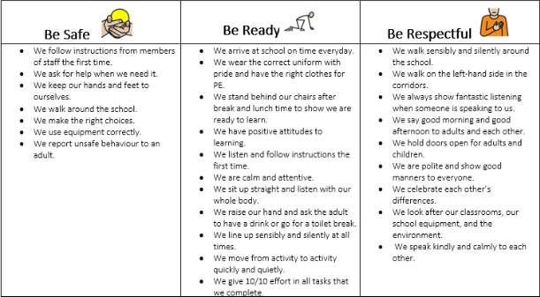
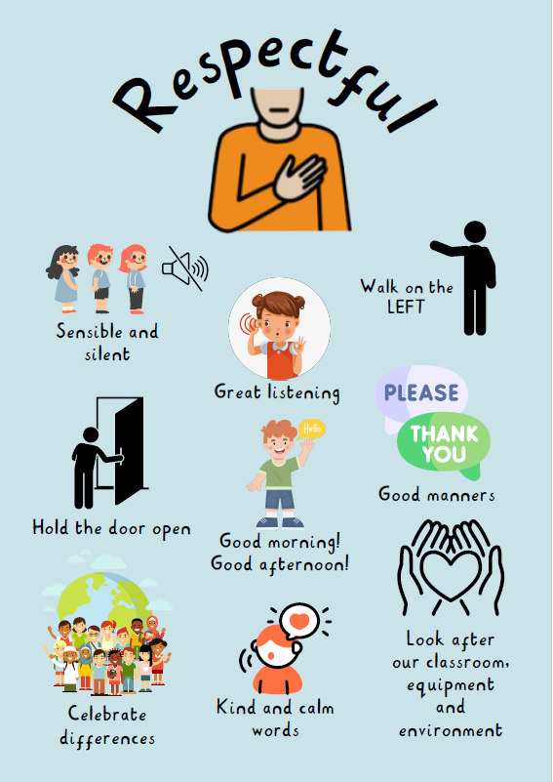
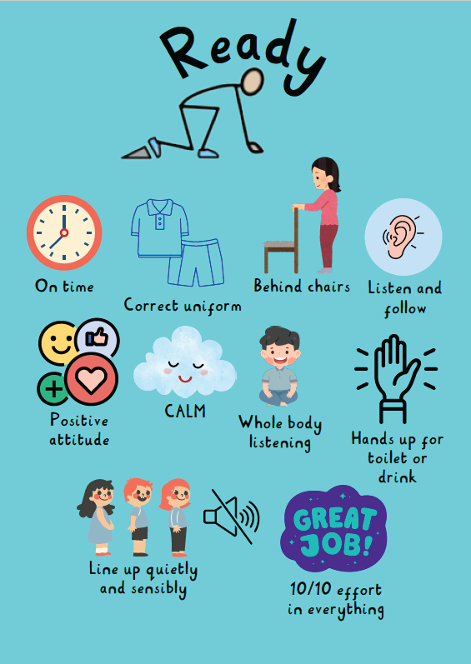
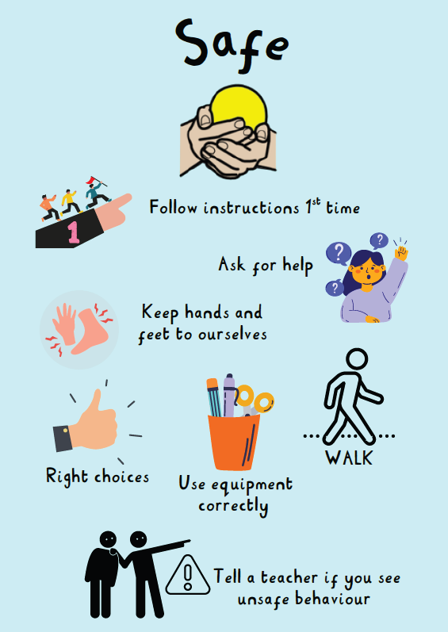

APPENDIX 2 – Our Routines.
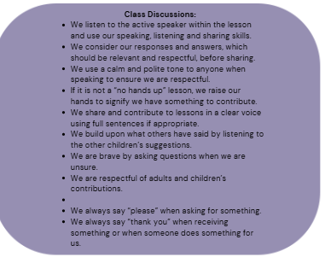
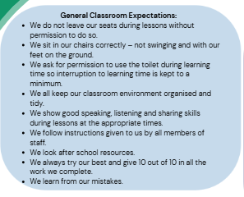
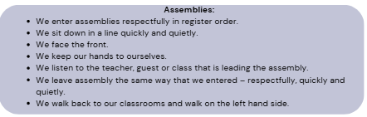
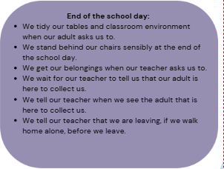
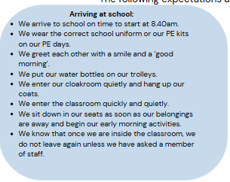
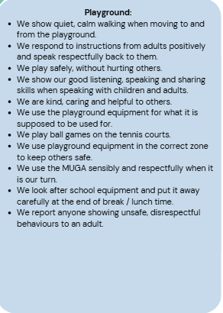
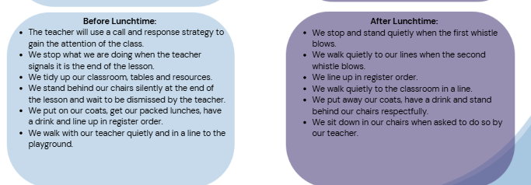
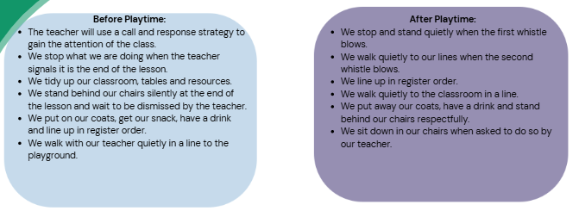
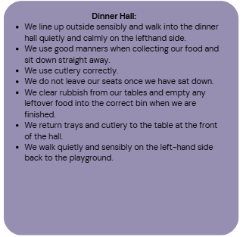
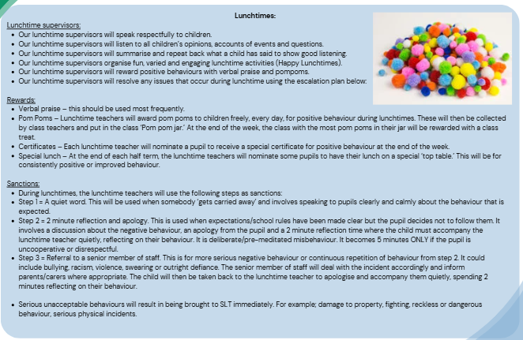
Lunchtime Behaviour Procedures

APPENDIX 3: Responding in the Moment

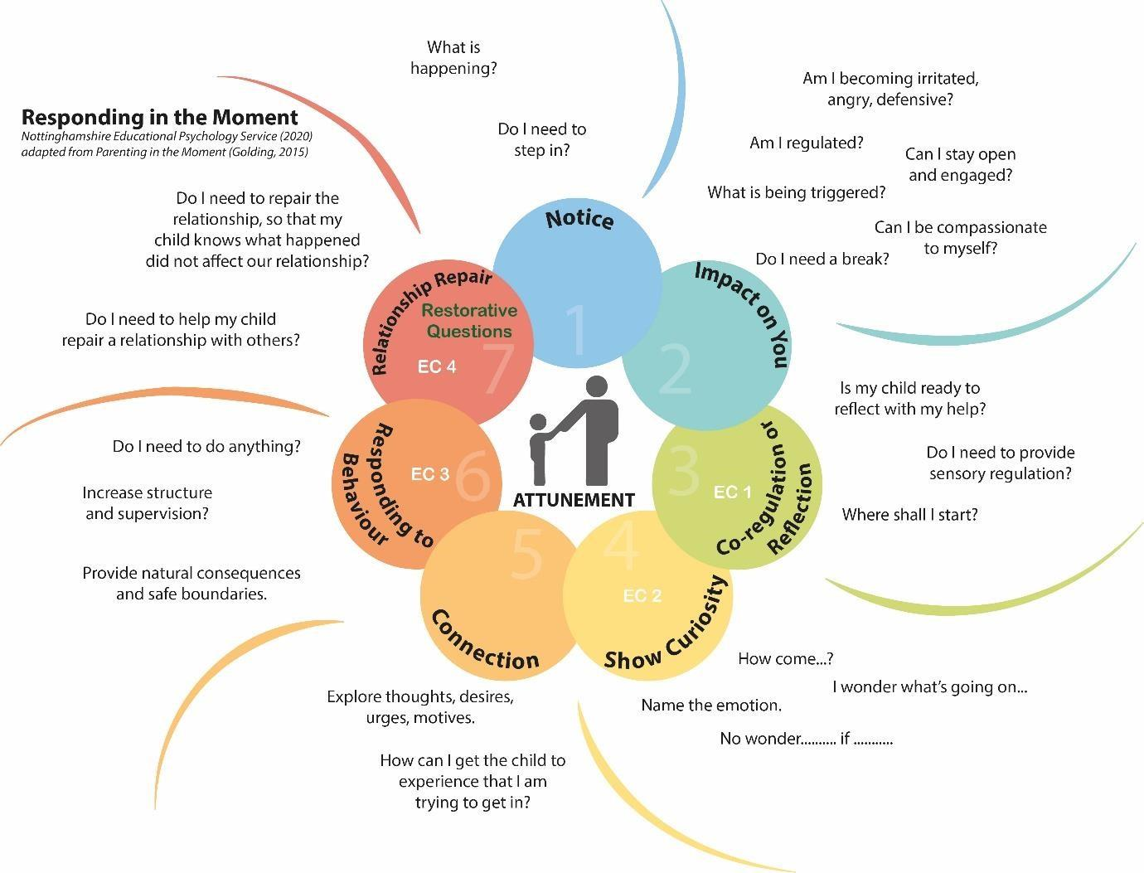

APPENDIX 4: Stages of Distress and Support
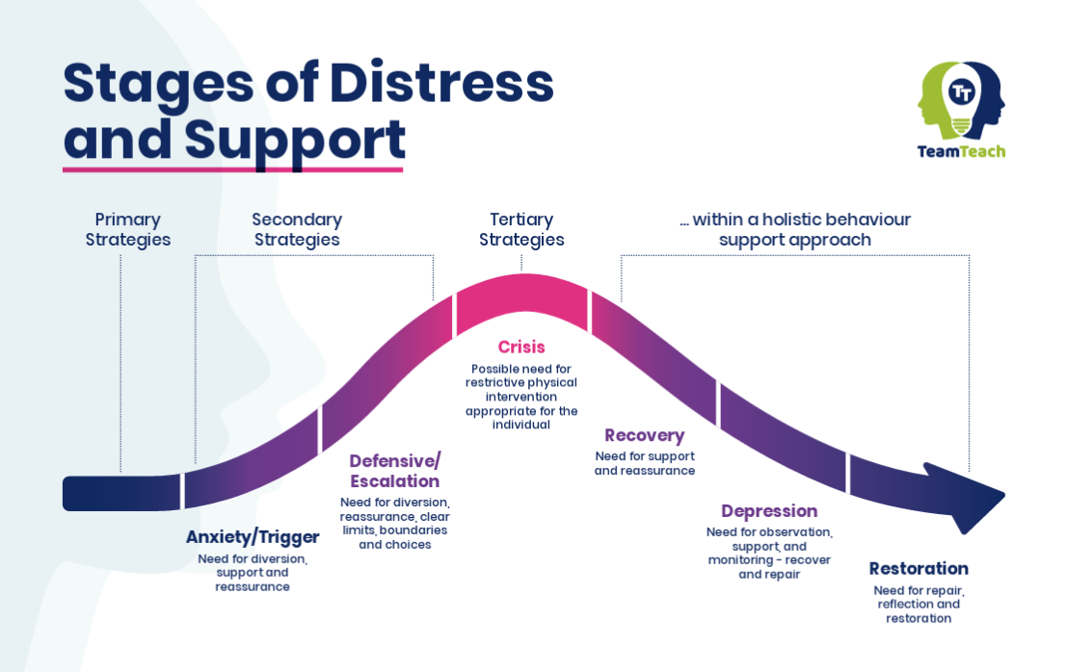

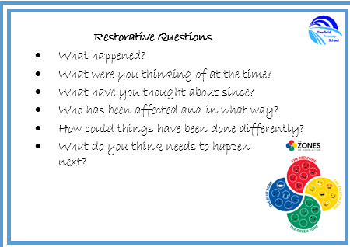
APPENDIX 5: Restorative Questions

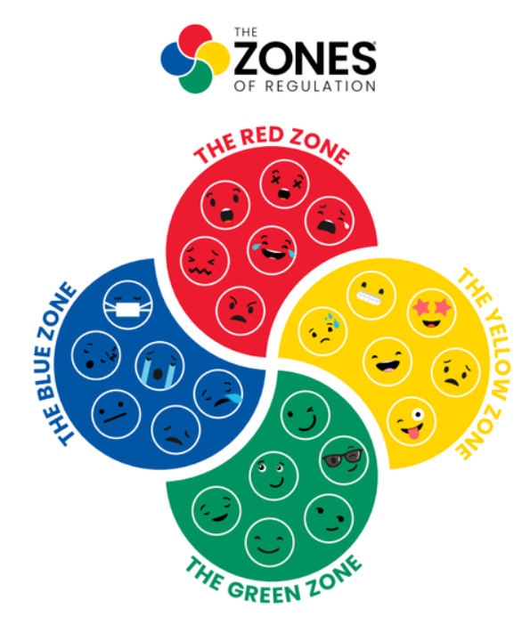

APPENDIX 6: Example Behaviour Plan

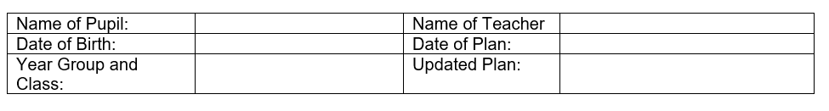

Team Teach techniques seek to avoid injury to the pupil, but it is possible that bruising or scratching may occur accidentally, and these are not to be seen necessarily as a failure of professional technique technique, but a regrettable and infrequent side effect to attempts to keep people safe during a critical incident.

Student Name:

Class Teacher:

Support:

Key Information to support child:

Preferred De-escalation Strategies:
(Describe CALM strategies that, where & when possible, should be attempted before positive handling techniques are used)
 | Try |  |  | Avoid | Notes and Key Scripts
Verbal advice/support |  |  |  |  | Allow *** time to process what you have said.  Give *** two clear choices using when/then  “It is this…. Or this…”  Stick to the two choices when you have given them. Do not keep changing them.  “I am here to help”  “Tell me what you are finding tricky”  “Lets go and…”  “I am here to listen”
Distraction
Reassurance
Planned Ignoring
Contingent Touch |  |  |  | X
Time Out Offer
Time Out Directed
Transfer to another adult
Reminder of Choices
Humour
Success Reminder
Removing an audience
Trigger Behaviours  (Describe common behaviours/situations which are known to have led to de-escalation techniques/positive handling being required. When is such behaviour likely to occur?) |  |  |  |  |  | Warning Signs  (Describe behaviours that may be observed)
Risk Assessment of Behaviours:
Description of Behaviour |  | How likely is the risk to happen?  High = Daily/more than once a day  Medium = weekly  Low = Less than once a week |  |  |  |  | How great is the risk to others?  High = Potential to serious injury to others, self and property  Medium = Some potential to injure and harm  Low = Prevents learning – no risk of injury
Preferred Handling Strategies (Tick as appropriate)
Holds/escorts in red must be documented on CPOMS and parents MUST be informed.
Single Person Holds and escorts |  |  |  | Two person holds and escorts
Caring C Guide |  |  |  | Friendly hold
Single person double elbow |  |  |  | Two person single elbow
Help hug |  |  |  | Figure of four
Knuckle Squeeze |  |  |  | Single elbow in chair
Half Shield |  |  |  | Small child guide
Manipulation of Jaw |  |  |  | Small Child Hold
Bar and Gate |  |  |  | Use of beanbag to support hold
Turn gather guide |  |  |  | Responding to spitting or biting
Opening the Oyster |  |  |  | Two person double elbow
Conductor |  |  |  | Response to deliberate dead weight
Are there any medical or emotional considerations?

Notes linked to child, holds and escorts (include key scripts to support):

Key Scripts:
We are here to help
We are keeping you safe because we care
We know you are finding it tricky right now
We can see that something is not okay.
We understand you are…let me help.
De-briefing process following incident:
- Debrief with staff
- During any type of debriefing, Emotion Coaching must be used to support *** to understand her anxieties/emotions/feelings better. It is important to explain to her what happened and how she was feeling at the time so that she can begin to identify her own emotions. The adults are to provide *** with strategies to help her to better manage her feelings if the situation were to arise again. This could be through Big Empathy Drawings or using Zones of Regulation.
- Ensure any first aid required is checked by a first aider.
Recording and notification:
All incidents to be recorded by each individual involved on CPOMS.
Parents to be notified when any physical intervention was required.
CPOMs to be authorised by a DSL/DDSL who was not involved in the incident. Assign the CPOMs to this person.
The undersigned have been involved in the design of this plan and agree to its implementation:
To be signed by the following:

Parent……………………………….
Teacher………………………………
Team Teach Trained Members of staff:
Headteacher………………………..

APPENDIX 7: Restrictive Intervention Recording Form

Incident and Child Details
Name of Child
Year Group and Class
Date
Time
Location of Incident
Name of staff completing form
Staff witnesses or others directly involved
Names of any other children involved
Does the child have an IBP?
Does the child have a PHP?
Is the child on the SEND register?
Area of SEND Need

Type of Restrictive Intervention (tick all that apply)
(Non-Force Restraint is blocking, directing movement, preventing exit. Guided Physical Intervention is when you are guiding a child to where you need them to go or away from a situation)
Seclusion
Physical Restraint
Non-Force Restraint
Removal of Mobility Aids
Guided Physical Intervention
Significant Use of Force

Incident Details
Incident Description
De-escalation techniques used (Examples include WINE model, PACE, Verbal advice/support, minimal language, distraction (if so, what), reassurance, planned ignore, time out offered, change of face, reminder of choices, humour, success reminder, removal of an audience).
Effectiveness of these techniques
Risk assessed that resulted in restraint (tick those that apply) | Risk of harm to other pupils  Risk of harm to staff  Risk of harm to property  Risk of harm to self
Rationale for Restrictive Intervention
Start Time/End Time and Duration of Restraint
Names of Team Teach Intervention Used
Effectiveness of Intervention Used
Any injuries during incident to staff or children and first aid provided?

Child Voice
(This must be obtained wherever possible, when the child is calm.)

Informing of Legal Guardian
How and when were those with parental responsibility informed?
Outcome of Discussion with parents/carers

Post Incident Support
(Was any support provided to the child or staff? Are any adjustments required to the child’s behaviour plan?)

Senior Leader Reviewer
Name and Signature
Date
Actions required following review

APPENDIX 8 – Above and Beyond School Values

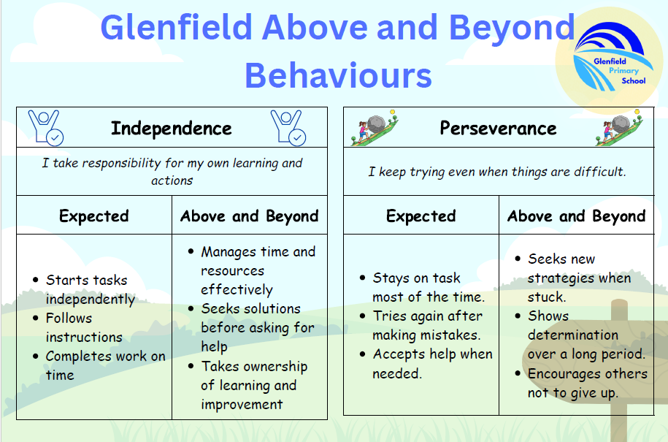

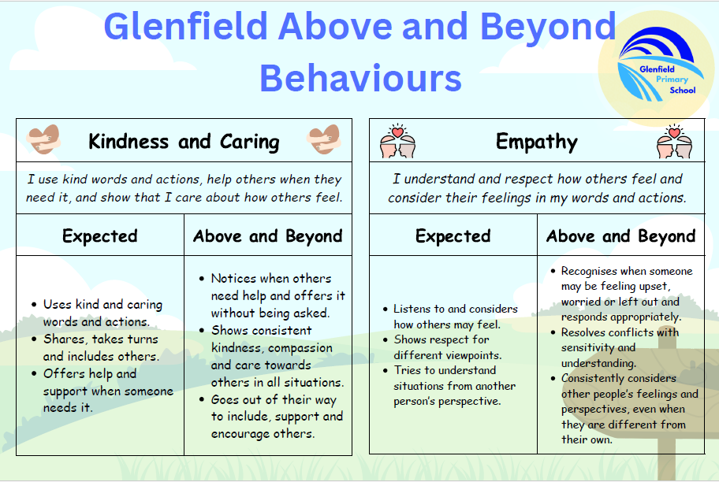

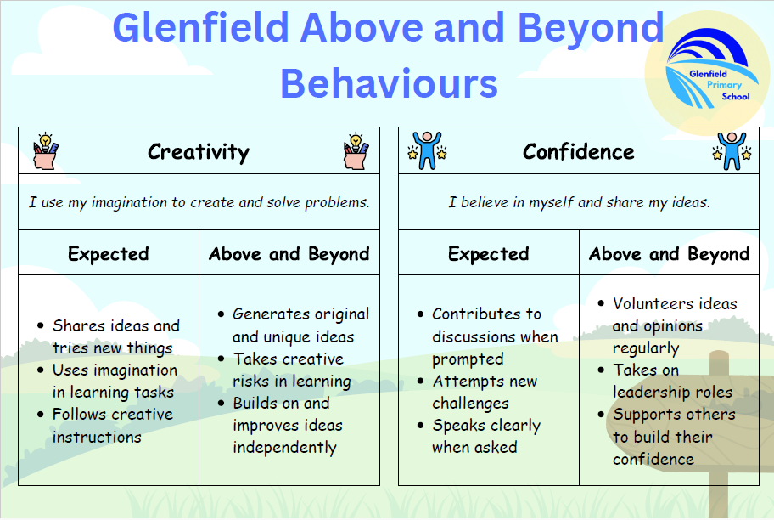

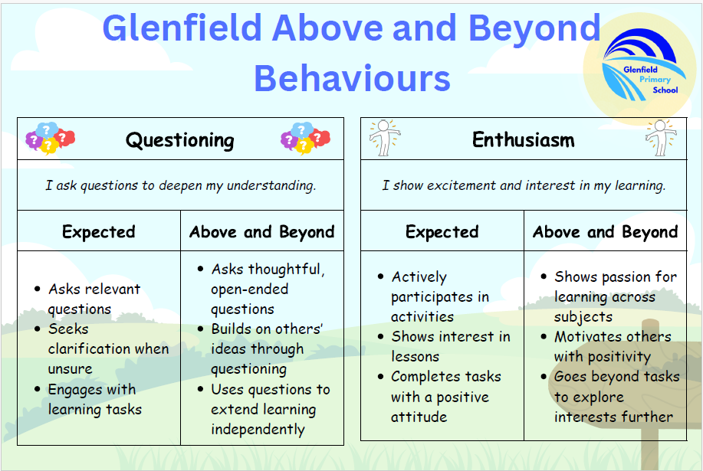

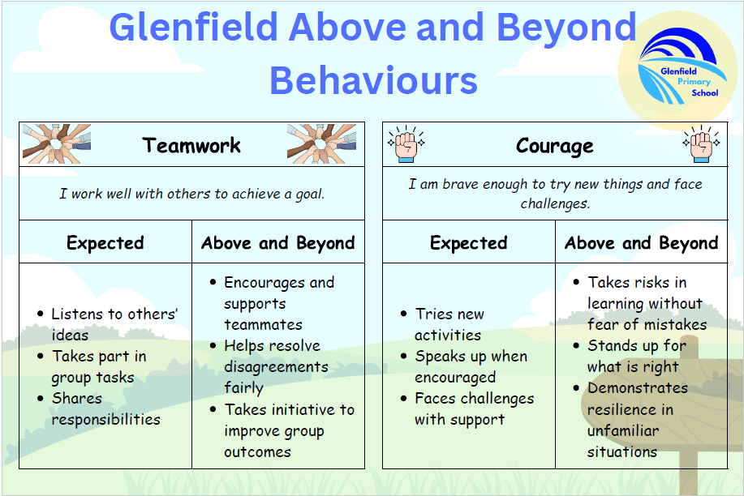

APPENDIX 9 – Reflection Discussion Recording Form



