Glenfield Primary School
Stamford Street, Glenfield, Leicester, LE3 8DL
Telephone: 0116 287 2188 Fax: 0116 287 4705
E-mail: office@glenfield.leics.sch.uk
Website: http://www.glenfield.leics.sch.uk

Headteacher: Mrs. Kathy Martin
Deputy Headteacher Mrs Sukhi Tibbles

Friday 15th September 2022
Dear parents and carers,

Thinkers
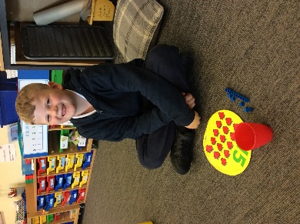
In Thinkers this week, we have been focusing on Giraffe’s Can’t Dance within our reading lessons. As Gerald the Giraffe goes through a lot of different emotions in the book, we talked about our feelings a lot and tried to use empathy to put ourselves into Gerald’s shoes. In literacy, we have once been using the Big Bad Pig story to write wanted posters about the crimes that the pig committed. We have also been focusing on place value of teen numbers in maths, particularly using dienes blocks to show the number of tens and ones of each number between 10 and 20.

Thinkers had a great opportunity to take part in some inclusive sporting games, playing a variety of different games, including wheelchair stuck in the mud. They really enjoyed this and talked very fondly of the fun they had in the lesson.

Topics that are going to be taught next week
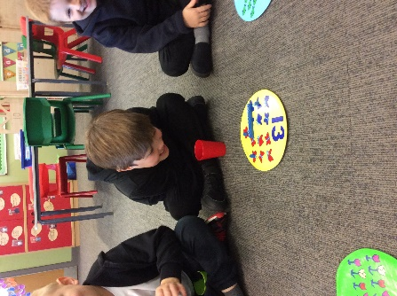
- Literacy: We will be continuing with The Three Little Wolves and the Big Bad Pig,
- Maths: We will be learning to partition numbers from 10-20, into how many tens and ones there and how to write this out using the partitioning method.
- Reading: For reading lessons next week, our focus book will be “The Loudest Roar”
- We will also be continuing talking about hot and cold places in Geography and comparing them to England. We will be starting our science topic of ‘healthy me’, discussing how humans and animals can be healthy through exercise and eating habits.

Our route to resilience word of the week for next week is going to be HUMOUR, as it will tie in nicely with our reading lessons.

Solvers

This week, the children have come up with lots of fantastic adjectives to describe the boy from ‘The Black Hat’ as well as his home in their writing lessons. They have planned out their descriptions and are ready to write these out next week. The children have been enjoying the story and it has led to some discussions about keeping animals captive.

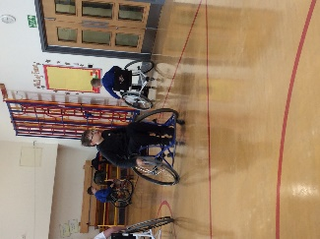
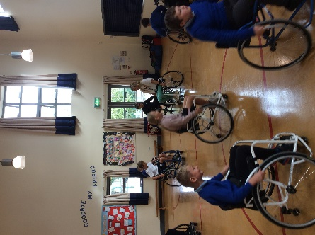
In maths, the Solvers have been recapping the four operations and looking at language that links to them. They have also been looking at balancing problems for example15 + 2 = ___ + 10.

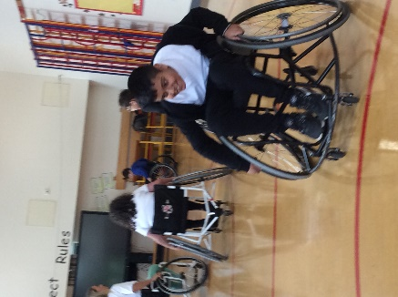
On Thursday, the children had the opportunity to take part in an inclusive sports roadshow. They had a fantastic time playing Tig, Stick in the Mud and Wheelchair Basketball. Lots of them have expressed interest in joining a local team. We will send out information about this very soon.

Topics that are going to be taught next week
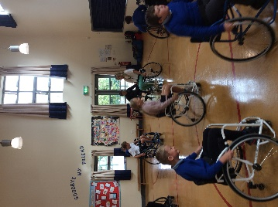
- Writing: We will continue to look at ‘The Black Hat’. The children will be using their plans created this week to write up their final pieces. Look out for pictures of these on next week’s newsletter.
- In maths, the children will be using their knowledge of placing numbers on a number line to round to the nearest 10 and 100.
- Reading: For reading lessons next week, our focus with be the ‘To the Edge of the World’. We will be moving onto this novel in our writing lessons soon too. Our class book is ‘Charlie and the Chocolate Factory’.
- In Geography, we will be locating he capital cities of the countries that make up the United Kingdom. In Science, we will be going on a rock hunt to discover all of the things that are made from rock in and around our school.

Our route to resilience word of the week for next week is going to be LISTENING.

If you have any questions, please continue to use those communication channels highlighted at the start of this newsletter.

Thank you for your continued support.

Speech and Language Team

