Year 2

Welcome! We are so excited for you to join us in Year 2. To help you prepare for learning in Year 2, we have thought of some challenges you can complete over the summer. We can’t wait to see the learning you complete! Remember to bring it in! |  |  | What’s the Price?  Ask your adult to borrow some coins so you can learn about money.  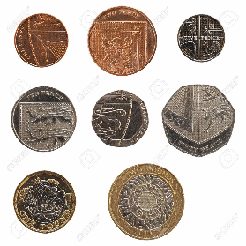  What is the value of each coin and notes?  Select a few coins and add them up to find the total.  For example, 10p+5p+2p=17p  Choose an amount and make that amount in different ways.  25p  20p+5p  10p+10p+5p
Learning to Multiply!

We know that this year you tried really hard to learn to count in 2s, 5s and 10s. As a summer challenge, we would like to see if you can now use this to begin to learn your times tables.

Can you learn your 2, 5 and 10 times tables before you begin Year 2?
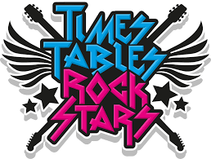
Sign in to your TTRockstars account and see if you can score highest in the class.
https://play.ttrockstars.com/auth/school/student

or alternatively

Use https://www.topmarks.co.uk/maths-games/hit-the-button to help learn your times tables.

Bonds to 10 and 20  Do you know all your number bonds to 10?  e.g. 1 + 9 =10  Do you know all your number bonds to 20?  e.g. 12 + 8 = 20  Make lists of number bonds. Practise remembering them. An adult at home could say a number and you say the number that goes with it.  E.g.  What goes with 4 to make 10?  What goes with 15 to make 20?  Alternatively, use https://www.topmarks.co.uk/maths-games/hit-the-button to help recall your number bonds quickly. | What’s the time Year 2?  Throughout your time in Year 2, we will be learning to tell the time on an analogue clock.  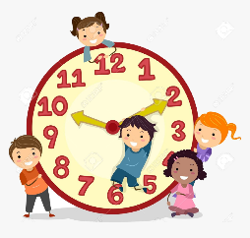  Over the Summer, we would like you to begin to learn to tell the time with an adult.  Begin by finding out what time you:  wake up  eat breakfast  have lunch  go to sleep  If you would like an extra challenge, you can try to learn to read the o’clock, half past, quarter past and quarter to times on an analogue clock! |  | Shape Monsters  In Year 2, we will be learning to name and describe lots of different 2D and 3D shapes.  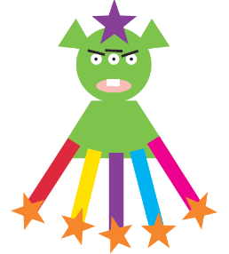  As a challenge, we would like you to create a shape monster using a range of different 2D shapes.  Can you label the shapes and describe their properties?  Think about how many sides and corners each shape has!
What’s the number?  In Year 2, we like to represent numbers in lots of different ways! This helps us to understand the place value of a number.  Pick a number up to 50.  Can you identify how many 10s and 1s are in those numbers?  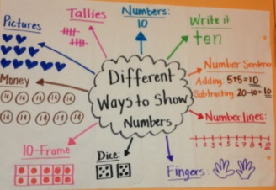  Draw them using dienes.  Represent them using jottings.  Can you write them as words?  Can you think of your own way to represent the numbers? |  | Addition  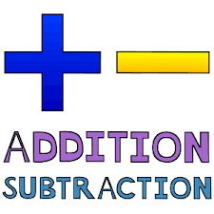  We love to add and subtract in Year 2!  For your challenge we would like you to add a 1-digit number to a 2-digit number.  Try and draw dienes to help you add your numbers together or use anything you can find round your house to help.  As an extra challenge, you could try to add three 1-digit numbers together!

